Programmer: Param A Ri
Instructor: Mrs. Jackson
Class: CSCI-1302
Date: 1/13/14

Quizes
Ch. 6:
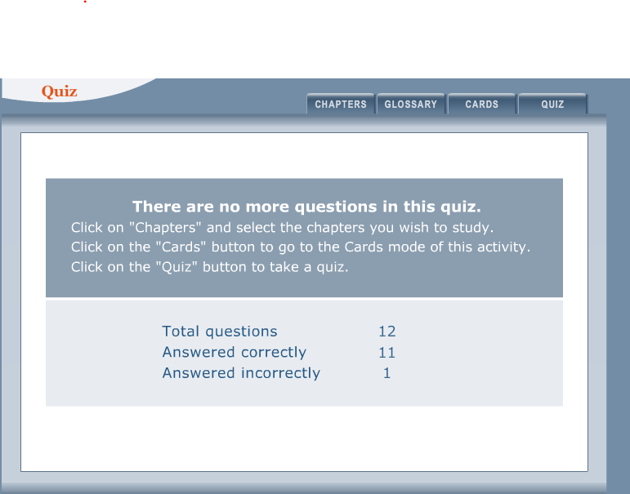

Ch 11:
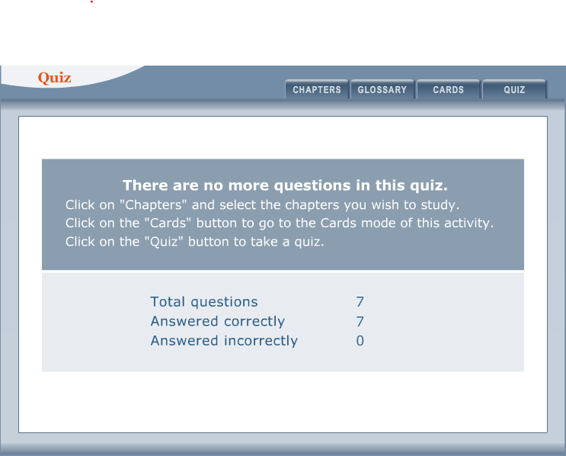

P 6.26:

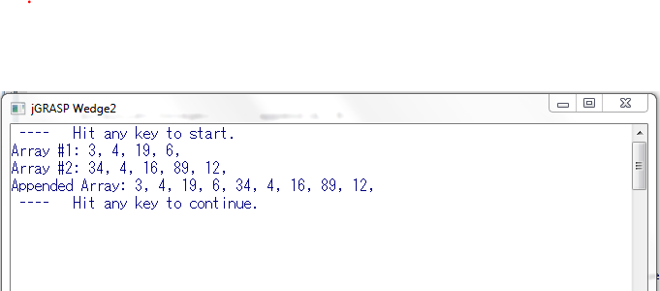

P 11.12:

